**Associate Designer Design Document**

Claire Yeash

# Introduction

Ratchet and Clank just saved Aleero City and the Hall of Heroes on Kerwan—their heroics officially making them Galactic Rangers. After their first Ranger training session, Ratchet and Clank talk to Captain Qwark who gives them a secret mission to the weapons lab on Nebula G34 as well as a robot factory on Arcturus, a small planet in the Solana galaxy. Qwark gives the duo the task of infiltrating the two hidden outposts to learn about and destroy the weapons and robots being built.

The Robot Factory level takes place in Titanus Station on Arcturus. Once the player gets the mission from Captain Qwark, they can travel to Arcturus immediately after completing Kerwan. Refer to Present Mechanics for more information regarding the abilities Ratchet needs to complete this level.

# Level Segment ObjectivesInfobot | Ratchet & Clank Wiki | Fandom

*Learn about the factory and the robots being built.*

* Subtasks

1. Explore the factory.
   1. Takes place in the main part of the factory until the final conveyor belt section.
2. Find the info bot in the operations room.
   1. Takes place on the final conveyor belt section and the combat encounter in the operations room.

* Reward
  + Infobot with Drek’s plans for the robots built in the factory. The Infobot flies out of a control panel to Ratchet in a short cutscene after the final combat encounter in the operations room.

# Present Mechanics

### *Movement Weapons and Gadgets*

* Run - Wrench
* Jump - Combustor
* Ledge grab - Fusion Grenade
* Heli-pak jump - Heli-pak
* Heli-pak glide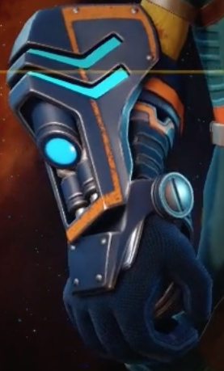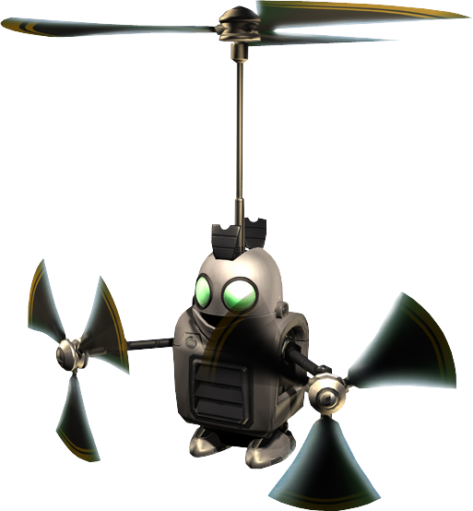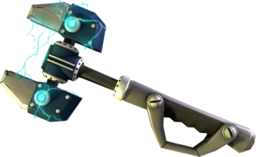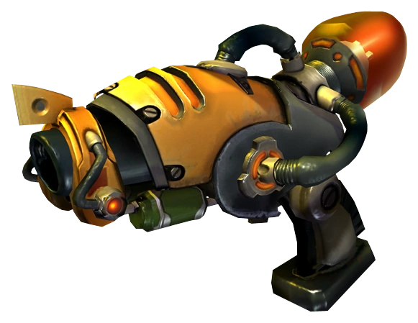

# EnemiesR&C (2016)

* Robomutts (encourages Omniwrench usage)
  + Size: 1 meter tall
  + Hit Points: 1
  + Movement Behavior: Charges at Ratchet and crowds around, biting and then pausing for 0.5 seconds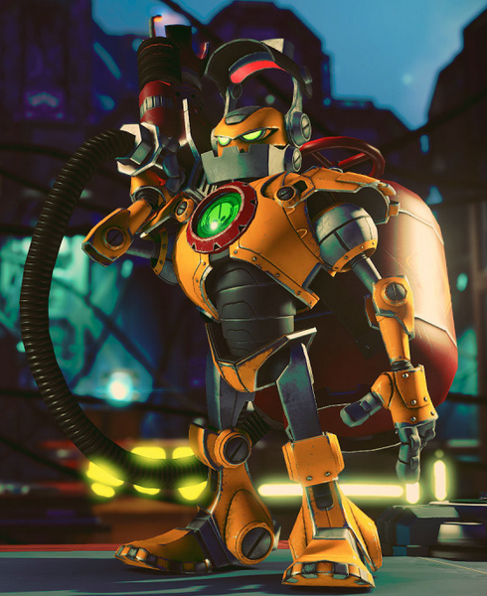
* Constuctorbots (encourages Combustor or Fusion Grenade usage)
  + Size: 3 meters tall
  + Hit Points: 10
  + Movement Behavior: Flanks Ratchet’s current location and slowly approaches while shooting at him with the flamethrower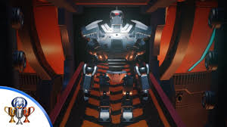
* Warbots (encourages Fusion Grenade usage)
  + Size: 4 meters tall
  + Hit Points: 20
  + Movement Behavior: Stays near the edge of the room and fires at Ratchet

### *Final Encounter*

The final encounter takes place in the operations room which is the final room of the level. The operations room is empty when Ratchet approaches except for the computers and control panels scattered about the room acting as cover. When Ratchet enters, a siren starts beeping and the first wave of the encounter starts. Refer to the Enemies section for details about each enemy type.

3 enemies spawn at a time from each spawn area in the operations room. There is a 0.5 second delay between each set of 3 from a singular spawn area.

#### Enemy Waves

* First wave (Starts when Ratchet enters the operations room)
  + 10 robomutts
  + 3 constructorbots
* Second wave (Starts when 3 enemies from the first wave are remaining)
  + 10 robomutts
  + 1 warbot
* Third wave (Starts when 5 enemies from the second wave are remaining)
  + 7 robomutts
  + 1 warbot
  + 2 constructorbots

# Important Level Points Explained

### Level Mechanics

* All conveyor belts move at 2m/sec. Refer to the level map for each respective direction.
* Ratchet cannot grab onto the edge of a conveyor belt.
* Ratchet cannot stand on top of the smashers.
* Ratchet can see through the bars of a smasher when it is lowered to better time his movement underneath.

### Level Section Notes

Refer to the below map in the Golden Path section for the corresponding section numbers.

1. Conveyor belts rotate 90 degrees clockwise. It takes 2 full cranks of the bolt crank to fully turn the conveyor belts.
2. The bottom edge of the smasher is 5m above the conveyor belt, stamps down at 16m/sec, and raises back up at 2.5m/sec. Refer to the level map pdf for a visual.
3. Conveyor belt platform raises from 4m to 9m. It takes 2 full bolt cranks to raise up the conveyor belt.

# Golden Path

